Part 1

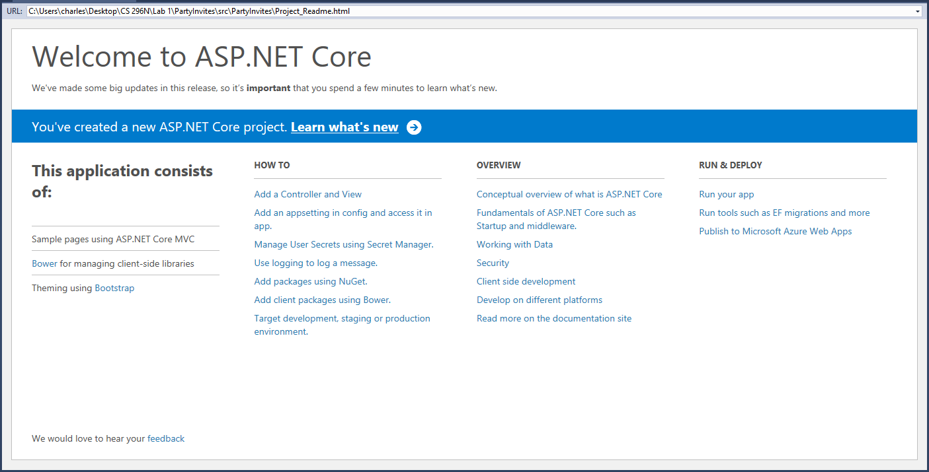

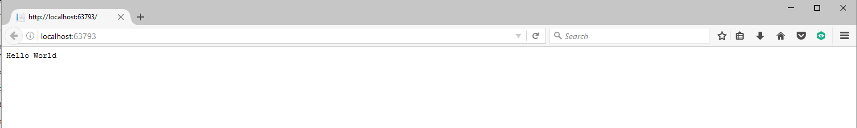

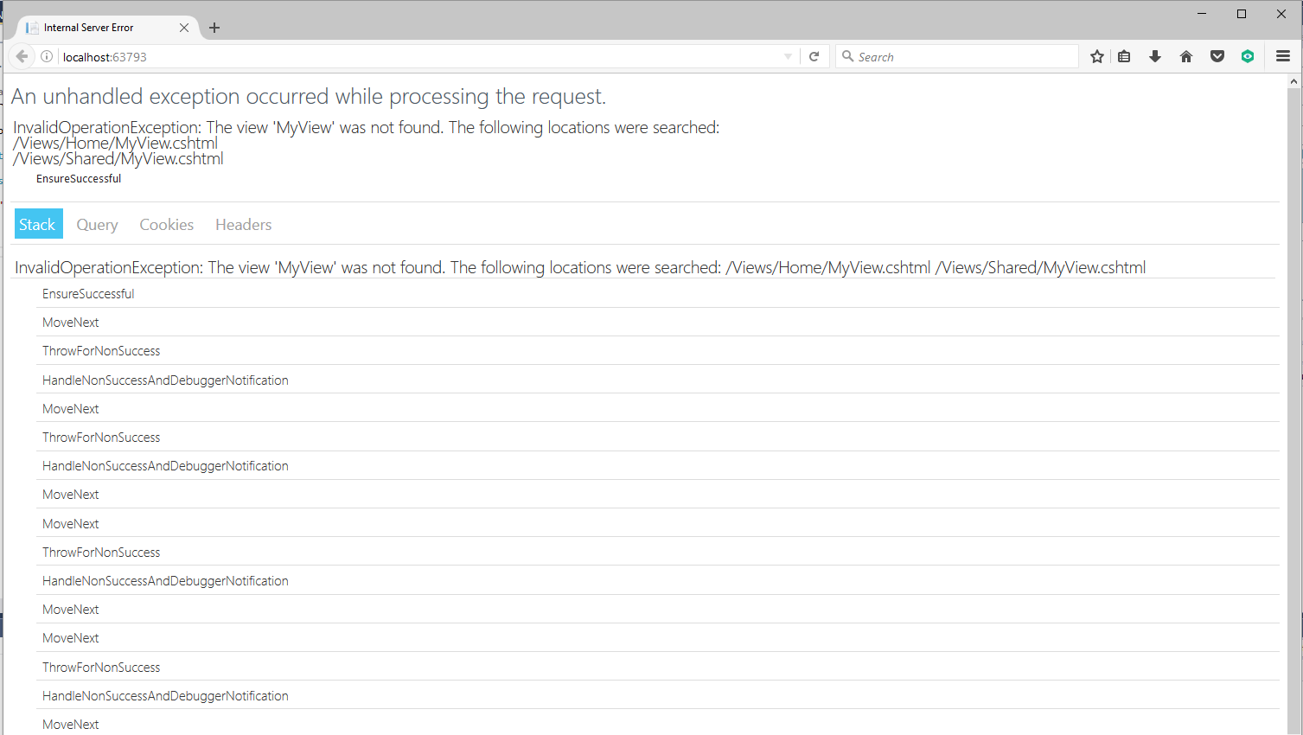





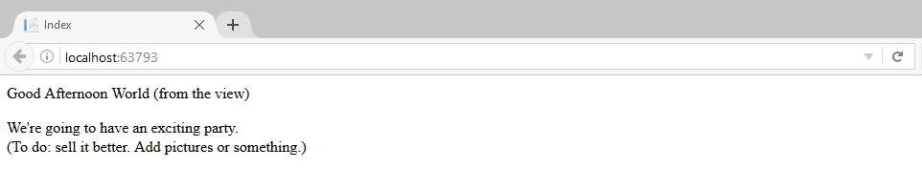

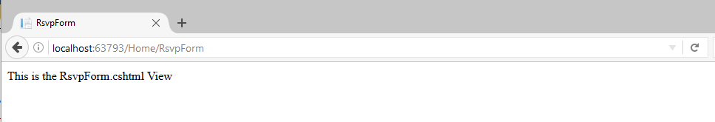

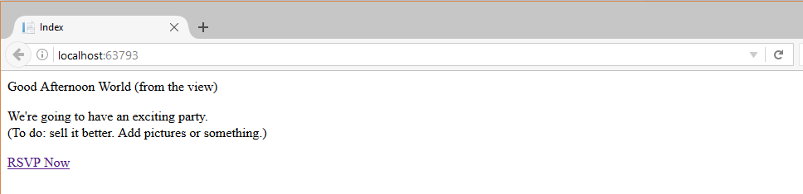

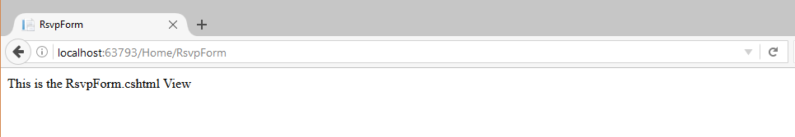

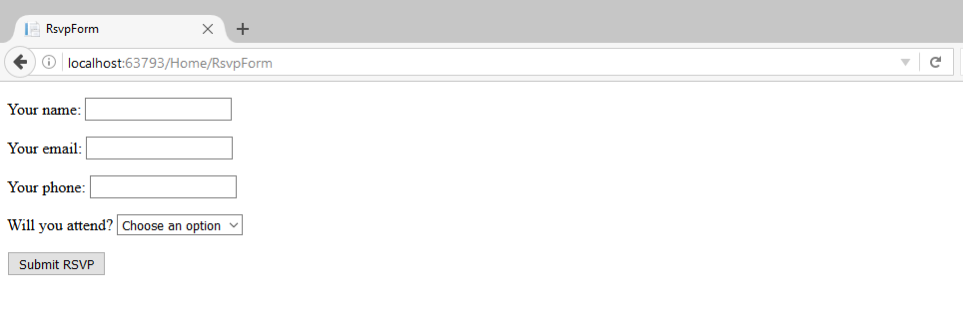

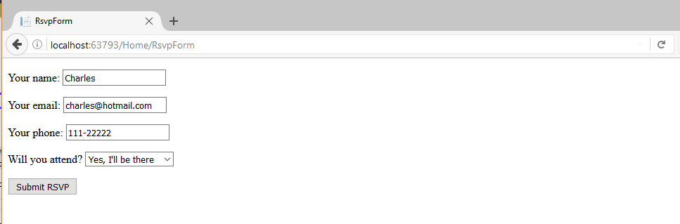

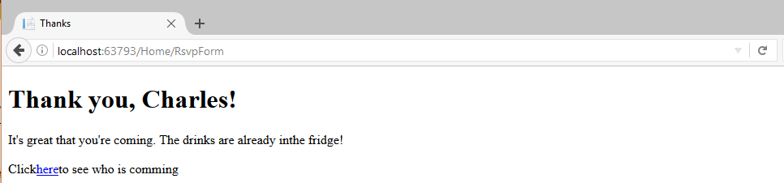

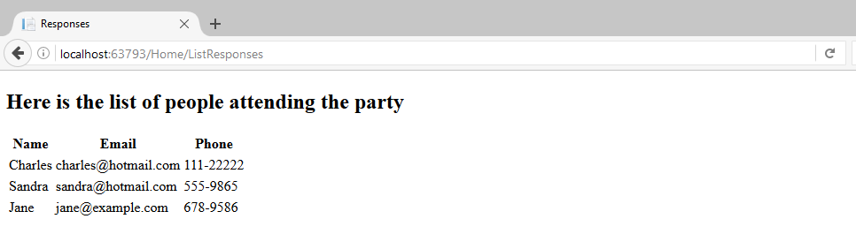

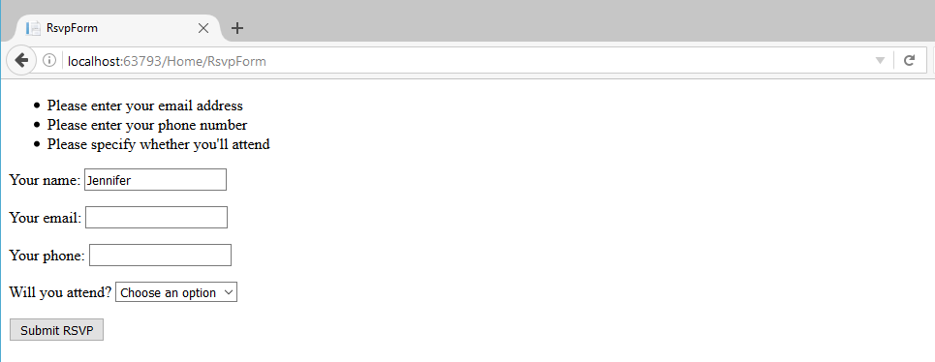

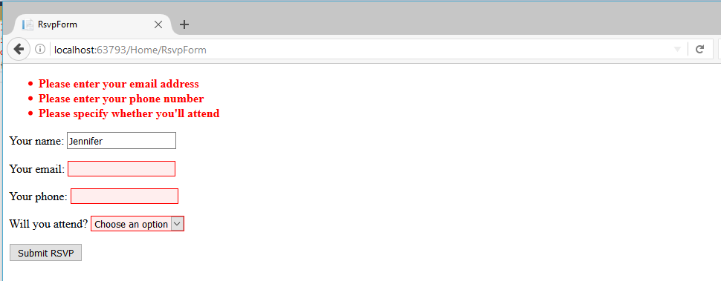

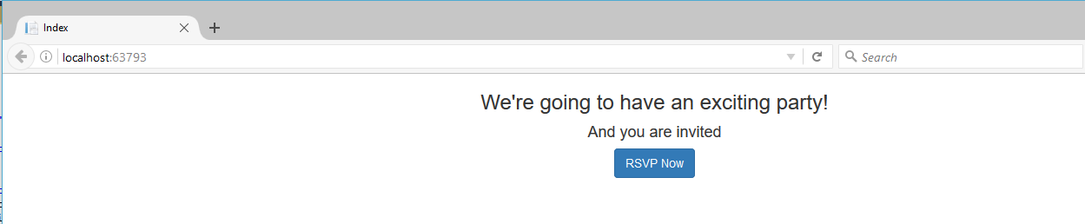

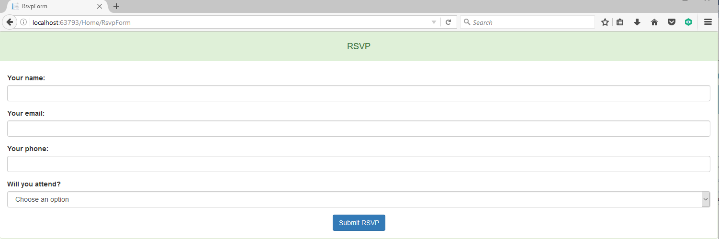

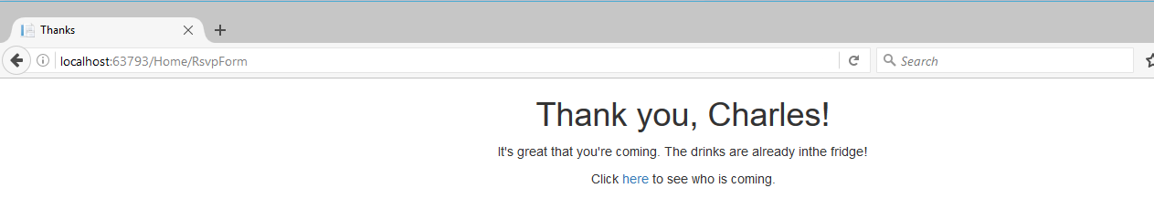

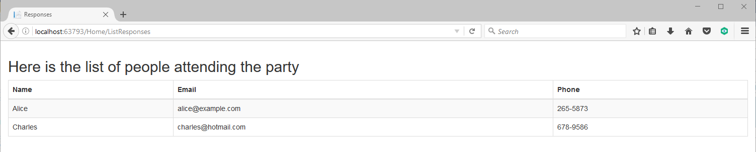

Part 2

My term project will be an online music web site. Customer can subscribe monthly service or they can make a purchase and download them. Customer can listen to the music before they make any purchase or become a member. Member will have unlimited to the music and create their own library. Member can also upload their own music so other member can hear it and provide any feedback. The site will have a blog and monthly news that member can create, discuss and participate in any music, concert event, artist, and other related topics.

Tables (5)

**Music**

ID#, Name of the song, Year, Artist, Album, Genre, Length, Rating, price

**Member**

Acct#, FName, LName, Street, City, State, Zipcode, Email, Phone#

**Order**

Order#

Acct#

Details (ID# in Music table)

Plan or price for the song

**Pricing**

Plan id#

Music id#

Price

**Login**

Acct#

UserName

Password

Pages (12)

Home page

Login page

Register page

Ordering page

About

Contact

Blog or chart

Monthly news

My library

Artists

Album

Your music

Site map

